LeafGuard AI:Predictive Modeling of Plant Stress Using Multisensor Data

Abstract
Plants are highly vulnerable to environmental stresses caused by heat, drought, and humidity fluctuations, which significantly reduce growth and yield. This project introduces LeafGuard AI, a predictive framework for plant stress that employs multisensory data and machine learning methodologies. The system uses environmental and physiological factors like temperature, relative humidity (RH), vapor pressure deficit (VPD), volumetric water content (VWC), plant weight, and electrical impedance to check on the health of plants. A representative dataset was utilized, succeeded by preprocessing and feature selection to optimize model efficiency and performance. A combination of Adaboost, decision tree, and random forest, called the Hybrid-AdapTree model, was suggested to make predictions more accurate and easier to understand. The Hybrid-AdapTree model outperformed the others in experimental tests using several regression metrics. It had a R² score of 0.999206 for predicting impedance, a low RMSE of 62.34, and a high Pearson correlation of 0.9996. The model was able to predict temperature with a competitive level of accuracy (R² ≈ 0.88). Also, feature selection makes the training process more efficient while keeping the accuracy high and lowering the amount of computation needed. The obtained results prove the reliability and efficiency of the suggested AI-powered framework in accurate processing of sensor data in order to detect plant stress.

Keywords: Plant stress detection ,Temperature ,Humidity ,vapour pressure deficit(VPD),volumetric water content(VWC),AdapTree algorithm, Machine learning.

I. Introduction
The changes in the physical state of the surrounding plants occur at even the slightest variations in such characteristics as temperature, relative humidity (RH), and electrical impedance in the surrounding plants. Such factors affect plant physiological functions including transpiration, nutrient absorption, metabolism and any changes lead to environmental stresses that result in low production quality and productivity of agricultural fields. This fact explains why predicting and analyzing the mentioned characteristics of the surrounding environment play an important role in creating effective and efficient farming techniques and developing advanced decision-making system.
One of the most reliable factors indicating the level of stress and overall health condition of plants is the electrical impedance factor which demonstrates any changes taking place within the internal plant physiology depending on the moisture content, cell structure and the environmental atmosphere. The same is about the temperature and RH indicators. They demonstrate an essential importance of the process of water usage and consumption. However, non-linearity of the above-mentioned parameters does not allow applying traditional models in predicting any future changes.
The rise of machine learning models has been attributed to their ability to model highly complex non-linear relationships in datasets. They, therefore, enable the solving of the above-mentioned challenges. Traditional regression models such as Multiple Linear Regression (MLR) are simple, cheap, and do not require much computational resources; however, they are ineffective at revealing complex interrelationships between different variables. On the contrary, complex prediction algorithms such as DTs, KNN, AdaBoost, MLP, and others enable better predictions but at the expense of increased costs, increased chances of overfitting, and higher sensitivity to dataset transformations. Ensemble learning techniques have gained popularity since they allow using multiple models together to improve the accuracy of predictions. The combination of Decision Tree learning algorithms and boosting algorithms (AdaBoost) in one prediction system has been referred to as AdapTree.
AdapTree works better than individual models, but it could work even better if more ensemble strategies were added and feature selection were improved.This project expands on the methodology suggested by Garg et al. in Sensors (2025) and presents an improved hybrid framework known as Hybrid-AdapTree. The suggested model uses a stacking-based ensemble method that brings together the best parts of Decision Tree, AdaBoost, and Random Forest models. The hybrid model effectively captures both linear and nonlinear relationships in the dataset by using a variety of learning mechanisms. This makes predictions more accurate and reliable.Feature selection is very important for making models less complicated, getting rid of features that are not needed or are redundant, and improving generalization performance.
This study employs MI to assess the relationship between input features and target variables. Based on the MI scores, less useful features like frequency are taken out, leaving a smaller set of features that includes phase, VPD, VWC, and weight. This optimized feature subset not only makes predictions more accurate, but it also cuts down on the amount of processing power needed by a lot. The input features are Frequency, Phase, Vapor Pressure Deficit (VPD), Volumetric Water Content (VWC), and Weight. The target variables are Impedance, Relative Humidity (RH), and Temperature. Before training the model, the dataset goes through steps like normalization, splitting into training and testing sets, and correlation analysis. A correlation heatmap is made to show how variables are related to each other. This gives you information about how important features are and how they depend on each other.
The proposed Hybrid-AdapTree model has been shown to be very accurate in experiments, especially when it comes to predicting impedance, with a R² value of over 0.999. The Hybrid-AdapTree with feature selection makes things even more efficient by cutting training time by about 53.8% while keeping performance the same or better. This shows how well ensemble learning and feature optimization work together.
This work also presents an Environmental Stress Index (ESI) that uses predicted parameters to sort stress levels into groups like low and moderate. This index helps make sense of model outputs in a practical way, which makes the system more useful for real-world farming uses.The results also show that while Hybrid-AdapTree and other complex models are great at predicting impedance, simpler models like KNN are great at predicting RH and temperature. This means that the right model may not always work for the right parameter, which shows how important it is to choose the right models for each use case.
In general, this project shows that using hybrid ensemble learning with feature selection is a strong way to predict environmental stress. The proposed framework not only makes predictions more accurate, but it also makes them faster, which makes it good for use in real-time embedded systems, IoT-based monitoring platforms, and smart agriculture applications.This work adds to the growing field of smart agricultural systems by offering a scalable and effective way to monitor and predict multiple environmental factors, which will help farming practices that are both sustainable and based on data.

II. Motivation: Research Purpose and Novelty Justification
The main goal of this research is to improve plant stress prediction systems by building on the AdapTree framework that was suggested. The foundational study illustrated that the amalgamation of Electrical Impedance Spectroscopy (EIS) with machine learning can proficiently forecast essential environmental parameters, including impedance, relative humidity (RH), and temperature. The original model, on the other hand, has some problems with feature optimization, computational efficiency, and model generalization, even though it is very accurate. The main goal of this research is to improve plant stress prediction systems by building on the AdapTree framework that was suggested. The foundational study illustrated that the amalgamation of Electrical Impedance Spectroscopy (EIS) with machine learning can proficiently forecast essential environmental parameters, including impedance, relative humidity (RH), and temperature. The original model, on the other hand, has some problems with feature optimization, computational efficiency, and model generalization, even though it is very accurate.
The base AdapTree model uses all of the input features without reducing them. It is mostly based on a boosting-based combination of Decision Tree and AdaBoost. This can make things more complicated than they need to be and cost more to compute. Also, the model doesn't fully use advanced ensemble methods like stacking, which can make performance even better on nonlinear datasets
1. Extension of Hybrid Ensemble Learning:
The proposed work presents a Hybrid-AdapTree model that enhances the fundamental AdapTree by integrating a stacking-based ensemble methodology. It uses Decision Tree, AdaBoost, and Random Forest models to find different patterns in data. This hybridization makes the model better at dealing with complicated nonlinear relationships and makes predictions more reliable than the original boosting-only method.
2. Combining feature selection with mutual information:
A significant innovation of this study is the incorporation of feature selection through Mutual Information (MI). This method only keeps the most important features, like phase, VPD, VWC, and weight, while the base paper keeps all of them. This cuts down on the number of dimensions, gets rid of extra information, and makes the model more accurate and efficient.
3. Better computational speed:
The proposed model cuts down on training time a lot by choosing the right features. The Hybrid-AdapTree with Feature Selection trains faster than the full hybrid model, making it better for real-time and embedded applications. This enhancement rectifies a limitation not explicitly acknowledged in the foundational study.
4. Better predictive performance across a number of factors:
The improved model is much better at making predictions (R² ≈ 0.999) than the base AdapTree and other regression models. The proposed model performs better than the base paper results (R² ≈ 0.993 for impedance) because it has lower error values. This shows that it is more generalizable and robust across impedance, RH, and temperature predictions.
5. Setting up a framework that is more useful and can grow with the business:
Combining hybrid ensemble learning, feature selection, and performance optimization makes the system more useful and able to grow. The addition of an Environmental Stress Index (ESI) also makes it easier to understand by turning predicted values into meaningful stress levels, making it more useful in the real world.

III. Literature Review
In precision agriculture, a lot of attention has been paid to using sensor technologies to keep an eye on plant stress. Plants grow and produce more when the temperature, humidity, light levels, and water availability are just right. Traditional ways of finding plant stress mostly use visual inspection and manual physiological measurements. But these methods are often time-consuming, subjective, and not good for monitoring large areas of farmland. Recent improvements in sensor technologies and AI have made it possible for automated monitoring systems to find plant stress conditions more quickly.
Numerous researchers have investigated imaging-based methodologies for the detection of plant stress. Liew et al. [1] examined the application of thermal imaging and fluorescence sensing methodologies to identify early plant stress conditions induced by pathogens and environmental factors. Their study showed that optical sensing techniques could pick up on signs of stress before they are visible to the naked eye. Zhang et al. [2] utilized UAV-based multispectral imaging to oversee maize crops and calculate the Crop Water Stress Index (CWSI). Their findings indicated that the integration of remote sensing and machine learning algorithms can proficiently identify water stress in crops. But imaging-based methods often need costly tools and complicated processing algorithms, which makes them less useful in farming settings where costs are low.
Environmental sensors are also very important for systems that keep an eye on plant stress. To learn more about the microclimate around plants, people often use sensors that measure things like humidity, temperature, and vapor pressure deficit. Wang et al. [5] examined the impact of fluctuations in temperature and humidity on plant physiological responses, concluding that environmental stress markedly influences metabolic processes and growth patterns in plants. Combining environmental monitoring with plant physiological sensing can give us better information about how stressed plants are.Machine learning methods are being used more and more in agricultural monitoring systems to look at complicated sensor data. Patel et al. [6] showed that sensor data can be used with machine learning algorithms to find plant diseases and keep an eye on the health of crops. Pradhan et al. [7] similarly proposed a machine learning framework for predicting abiotic stress-responsive microRNAs in plants utilizing Support Vector Machines (SVM). Their model was able to predict stress with an accuracy of over 80%, showing that machine learning could be useful for this kind of task.
Recent research has investigated sophisticated machine learning models for forecasting plant stress conditions. Akbari et al. [8] created a machine learning framework that uses molecular markers and phenotypic traits to sort barley genotypes based on how well they can handle drought and salinity stress. Their neural network-based model had a R² value of more than 0.99, which shows that AI-based models work well in agricultural research. Researchers have also looked into ensemble learning methods, which combine several models to make predictions more accurate.A lot of the research that has already been done on plant stress monitoring only looks at one stress factor at a time or only uses one type of sensor, like an imaging sensor or an environmental sensor. This makes it hard for these studies to fully understand how plants respond to changes in their environment.
Traditional machine learning models often have trouble figuring out how environmental conditions and plant physiological signals are related because plant stress is caused by many factors that affect each other. Recent research has focused on integrated frameworks that combine data from multiple sensors with advanced machine learning techniques to get around these problems.These developments highlight the need for data-driven approaches that integrate sensor technologies with machine learning algorithms to enable real-time plant stress detection and improve decision-making in precision agriculture.

IV. Methodology

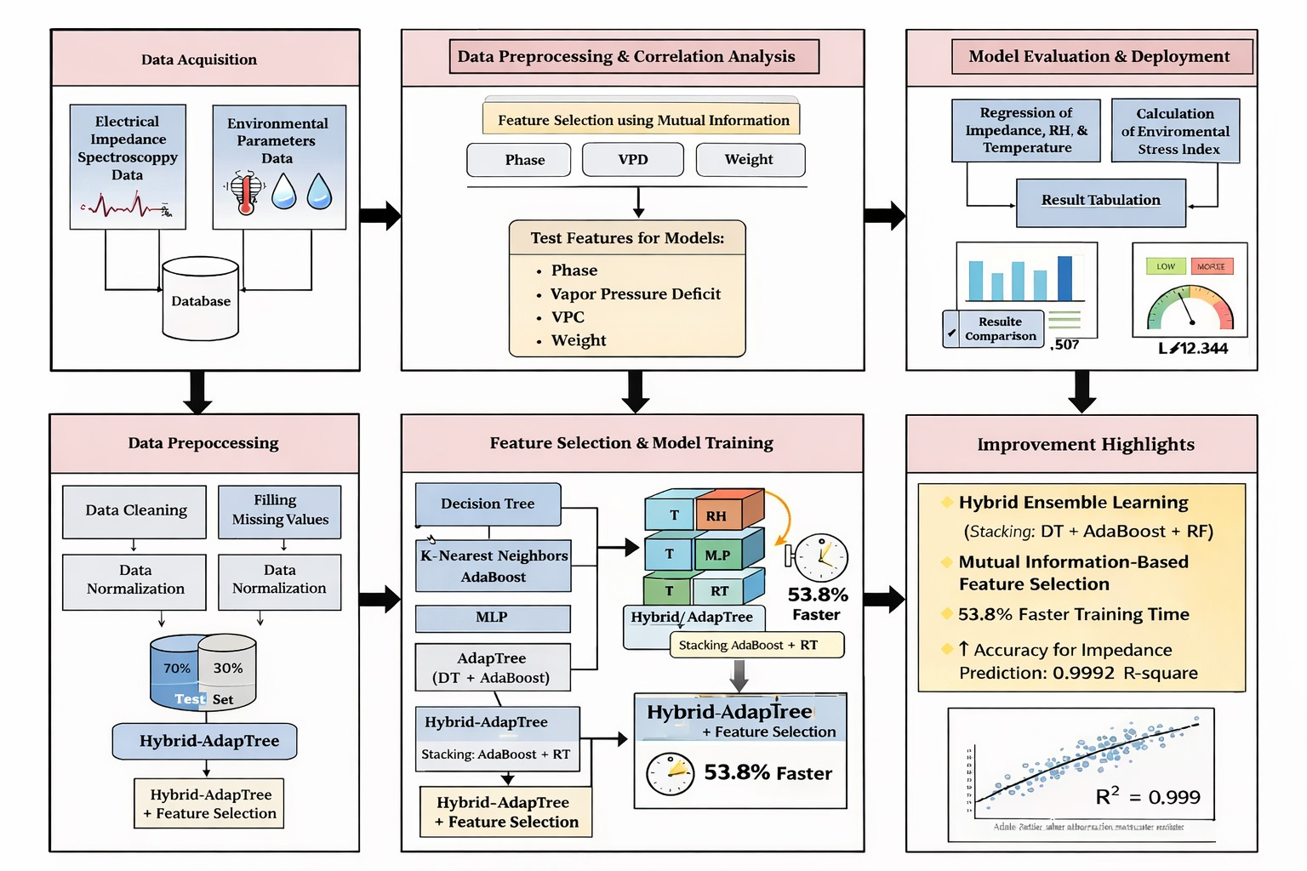

The proposed system follows a structured workflow starting from data acquisition to model evaluation and performance improvement using hybrid ensemble techniques.

1.Data Acquisition:

The process begins with collecting data from two primary sources: Electrical Impedance Spectroscopy (EIS) signals and environmental parameters such as temperature, humidity, and moisture-related variables. These data sources are combined and stored in a unified database for further processing. This integration allows capturing both plant physiological responses and environmental conditions.

2. Data Preprocessing & Correlation Analysis:

The collected data is preprocessed to ensure quality and consistency. This includes data cleaning to remove noise, handling missing values, and normalization to bring all features to a common scale. A correlation analysis is then performed using a heatmap to understand relationships between variables. Based on this, feature selection is carried out using Mutual Information, where important features such as Phase, VPD, VWC, and Weight are selected for further modeling.

3. Feature Selection & Model Training:

The selected features are used to train multiple machine learning models including Decision Tree, K-Nearest Neighbors (KNN), AdaBoost, and Multi-Layer Perceptron (MLP). An ensemble model called AdapTree is developed by combining Decision Tree and AdaBoost. Further, a Hybrid-AdapTree model is implemented using a stacking approach that integrates AdaBoost and Random Forest to enhance prediction capability. Feature selection is also applied within this hybrid model to reduce complexity and improve efficiency.

4. Model Evaluation & Stress Calculation:

The trained models are evaluated using regression techniques to predict impedance, relative humidity (RH), and temperature. The results are tabulated and compared using performance metrics such as R², RMSE, and MAE. Based on the predicted values, an Environmental Stress Index (ESI) is calculated to classify plant stress levels, providing meaningful insights for real-world applications.

5. Improvement Highlights:

The proposed Hybrid-AdapTree with Feature Selection demonstrates significant improvements over conventional models. It achieves high prediction accuracy, especially for impedance (R² ≈ 0.999), and reduces training time by approximately 53.8%. The combination of hybrid ensemble learning and Mutual Information-based feature selection results in a more efficient and robust model suitable for real-time applications.

A. Model Training
Model training is the process of creating machine learning models that can accurately predict environmental stress parameters like impedance, relative humidity (RH), and temperature by learning patterns from the input dataset. This study employs multiple regression models to evaluate and contrast their predictive efficacy.
At first, standard models like Decision Tree (DT), K-Nearest Neighbors (KNN), Multivariate Linear Regression (MLR), AdaBoost, and Multi-Layer Perceptron (MLP) are made. The Decision Tree model divides the dataset repeatedly in order to minimize prediction error. This lets it find nonlinear relationships in plant stress data. KNN predicts the output by taking the average of the closest data points in the feature space. This makes it good for recognizing patterns in small areas.The Multivariate Linear Regression (MLR) model is used as a baseline approach, where the relationship between input features and outputs is expressed as:
yi = bi0 + bi1x1 + bi2x2 + bi3x3 + bi4x4 + bi5x5 + ei
where yi represents the output variables (impedance, RH, temperature), xj are input features, bij are regression coefficients, and ei is the error term.
AdaBoost is implemented as an ensemble technique that improves model performance by combining multiple weak learners. It iteratively adjusts weights to focus more on incorrectly predicted samples. The final prediction is computed as:
ŷ(x) = Σ (alpha_t * ht(x)) for t = 1 to T
where ht(x) is the prediction of the t-th weak learner and alpha_t is its weight.
The MLP model can also find complicated nonlinear relationships by using multiple hidden layers and activation functions. This makes it good for working with data that has a lot of dimensions.To make predictions even more accurate, an ensemble model called AdapTree is made by combining Decision Tree and AdaBoost. This model makes generalization better by lowering bias and variance. The prediction can be shown as:
ŷ(x) = alpha1 * hDT(x) + alpha2 * hAdaBoost(x)
where hDT(x) and hAdaBoost(x) represent predictions from Decision Tree and AdaBoost respectively.
A stacking-based ensemble approach is also used to suggest a Hybrid-AdapTree model. This model uses a combination of Decision Tree, AdaBoost, and Random Forest to accurately capture both linear and nonlinear relationships.Additionally, feature selection is used to get rid of features that aren't as important and lower the number of dimensions. This makes the computer work faster and cuts down on training time while still making accurate predictions.
We use the prepared dataset to train all of the models and then test them using performance metrics like R², Mean Squared Error (MSE), Root Mean Squared Error (RMSE), Mean Absolute Error (MAE), and Pearson Correlation Coefficient (PCC). These metrics make sure that the model's performance is fully evaluated.The suggested Hybrid-AdapTree with Feature Selection is more efficient and has better predictive power, making it a good choice for real-time environmental stress prediction

B. Data Analysis
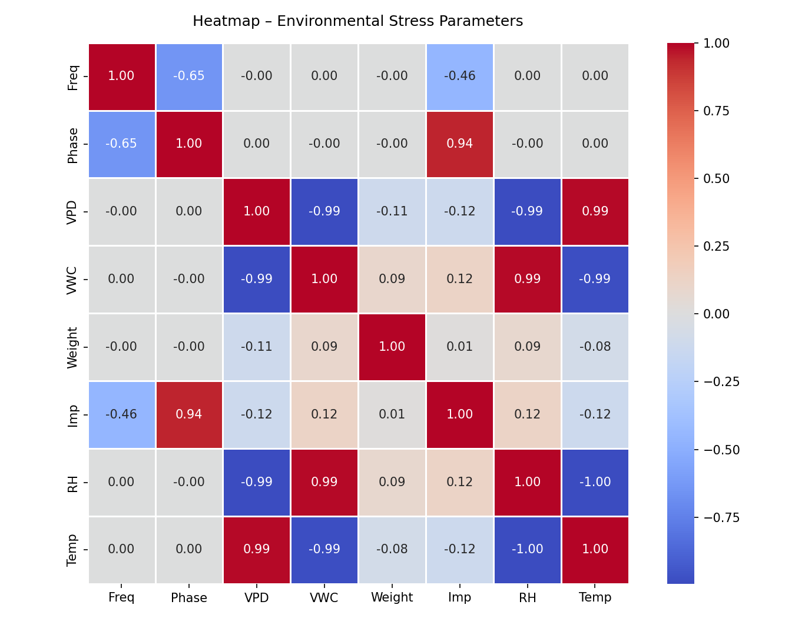
Figure1.Heatmap for environmental stress parameters.
A heatmap is a way to show how different environmental and electrical factors are related to each other. It makes it easy to see how variables are related to each other. The color intensity in the generated heatmap shows the strength and direction of the correlation. Higher positive values show strong direct relationships, while negative values show inverse relationships.
From the heatmap, a strong positive correlation is observed between Phase and Impedance (≈ 0.94), indicating that phase plays a significant role in determining impedance behavior. Similarly, VPD and Temperature show a strong positive relationship (≈ 0.99), suggesting that temperature variations are closely associated with vapor pressure deficit. On the other hand, a strong inverse relationship is observed between VPD and VWC (≈ -0.99), as well as between RH and Temperature (≈ -1.00)**, which reflects the natural environmental dependency where increasing temperature reduces relative humidity.Also, VWC has a strong positive correlation with RH (about 0.99), which means that the amount of moisture in the air directly affects the humidity levels. Frequency has a weak correlation with most parameters, but it has a moderate negative correlation with phase (≈ -0.65) and impedance (≈ -0.46). This suggests that it doesn't add much to the prediction.
The heatmap is also a useful diagnostic tool for finding features that are not needed or are not as important. This analysis shows that some variables, like frequency, have weaker relationships with target parameters than in the base paper, where all features were kept. This information backs up the idea of using feature selection in the proposed work to make the model work better and cut down on unnecessary information.
The heatmap shows that the chosen features have meaningful connections to the target variables and that environmental parameters are strongly linked to each other. This analysis helps you understand how the data is organized and gives you a starting point for making accurate and useful predictive models.

C. Data Collection
The collected dataset is systematically preprocessed to guarantee high-quality input for machine learning models. The first step is to combine the raw sensor data from electrical impedance measurements and environmental monitoring systems into one dataset. Next, the data is cleaned up to get rid of any noise or inconsistencies that could hurt the model's performance.
To keep the dataset's integrity and avoid losing important information, missing values are handled with the right imputation methods. After cleaning, the data is normalized so that all the feature values are on the same scale. This makes the model converge and stay stable. This step is very important because the dataset has parameters like frequency, impedance, and temperature that have different units and ranges.
After preprocessing, the dataset is split into two parts: a training set and a testing set, with 70% going to the training set and 30% going to the testing set. The training set is what you use to make the models, and the testing set is what you use to see how well they work on data they haven't seen before. This makes sure that the models work well in general and don't fit too closely to the data.
Also, Mutual Information is used for feature selection to look at how input features and target variables are related. This analysis gets rid of features that aren't as important, which cuts down on redundancy and speeds up computations. This step makes the model work better by only looking at the most important parameters.

Table 1: Sample dataset
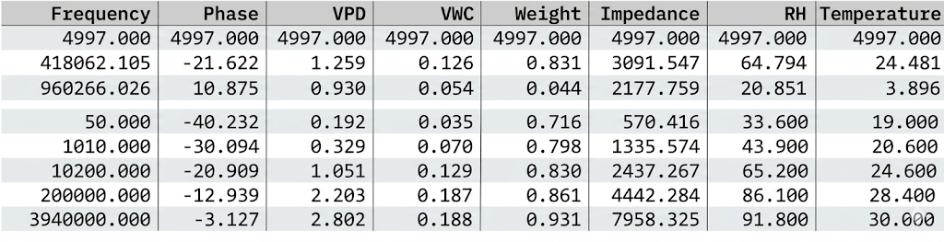

V. Results and Discussion
The performance of various machine learning models for predicting environmental stress parameters—impedance, relative humidity (RH), and temperature—is presented in Tables 1–3. The models evaluated include conventional techniques such as Decision Tree (DT), K-Nearest Neighbors (KNN), Multiple Linear Regression (MLR), AdaBoost, Multi-Layer Perceptron (MLP), along with the proposed Hybrid-AdapTree models. The evaluation is carried out using standard regression metrics including R², Mean Squared Error (MSE), Root Mean Squared Error (RMSE), Mean Absolute Error (MAE), and Pearson Correlation Coefficient (PCC).
Table 1: Comparison of regression models for impedance parameter of environmental stress
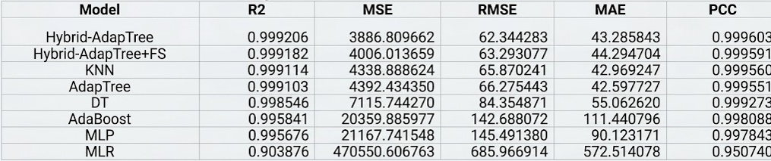
The proposed Hybrid-AdapTree model had the best prediction accuracy for the impedance parameter, with a R² value of 0.999206 and a PCC of 0.999603. It had much lower error values than baseline models (RMSE: 62.34, MAE: 43.28). The Hybrid-AdapTree with Feature Selection worked about the same, but it was a little less accurate and a little more efficient. Traditional models like MLR did not do well, with a low R² of 0.903876 and very high error values. This shows that they could not find nonlinear relationships. The KNN and AdapTree models did well, but the proposed hybrid model was still a little better. These results clearly show that the hybrid ensemble method improves prediction power by combining several learners in a useful way. The results show that the Hybrid-AdapTree model is especially good at predicting impedance, which is the most important factor for finding plant stress.
Table 2: Comparison of regression models for humidity parameter of environmental stress
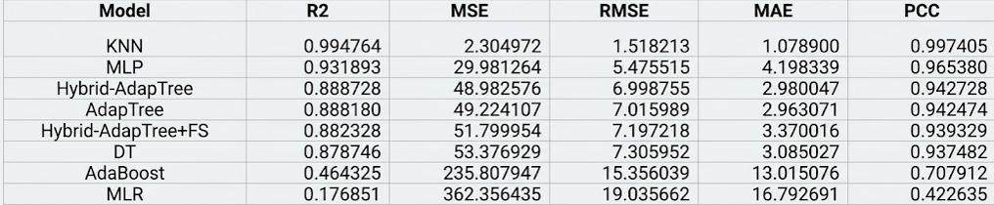
When it comes to predicting relative humidity (RH), KNN had the highest R² value of 0.994764, which was better than any other model for this specific parameter. The suggested Hybrid-AdapTree and AdapTree models, on the other hand, also did well, with R² values around 0.88. The hybrid models didn't do as well at predicting RH, which suggests that simpler models like KNN might be better at capturing humidity patterns. This could be because RH data is smoother and less complicated.
KNN once again had the best accuracy for predicting temperature, with a R² of 0.988274. The Hybrid-AdapTree with Feature Selection came in second, with a R² of 0.884201. The Hybrid-AdapTree and AdapTree models also gave consistent results, with R² values close to 0.88. The fact that KNN has lower error values shows that it can effectively model changes in temperature. But hybrid models still do well at generalizing across all parameters, while single models only do well in certain situations.
The AdapTree model also did a better job of predicting impedance because it could capture complex nonlinear physiological relationships. The addition of hybrid stacking makes this ability even better.The impact of feature selection is another important contribution. The Hybrid-AdapTree with Feature Selection gets almost the same accuracy as the full hybrid model, but it cuts down on training time by about 53.8%, making it better for real-time use. This shows that getting rid of less important features makes the computer work better without hurting performance too much.
Table 3: Comparison of regression models for temperature parameter of environmental stress
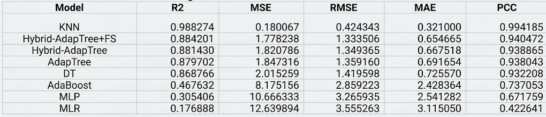
The proposed Hybrid-AdapTree model works best overall, especially for predicting impedance, even though KNN works well for RH and temperature. Combining hybrid ensemble learning with feature selection greatly improves both accuracy and efficiency. This makes the proposed method more reliable and better for monitoring environmental stress in real time.These results show how important it is to use more than one machine learning method and to optimize feature sets in order to get better predictive performance. The proposed hybrid framework is a more advanced and useful solution for precision agriculture applications because it is more accurate, has fewer errors, and is more efficient at computing than the base AdapTree model

VI. Validation of the Proposed Work

A. Feature Importance
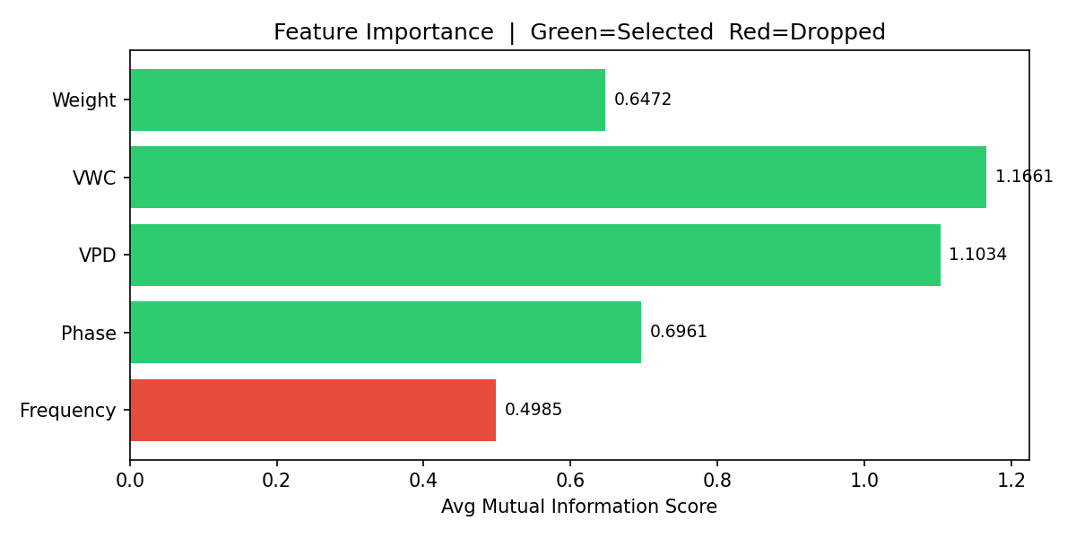
The Mutual Information (MI) method was used to do the feature importance analysis and see how much each input variable helped predict environmental stress parameters. The feature importance plot shows that Volumetric Water Content (VWC) and Vapor Pressure Deficit (VPD) have the highest relevance scores of 1.1661 and 1.1034, respectively. This shows that they have a big effect on predicting impedance, relative humidity, and temperature. These features are very important for stress analysis because they show how plants and water interact and how the environment affects them.
The Phase parameter (0.6961) and Weight (0.6472) are also somewhat important, which means they help to capture changes in plants' physiology. So, these features were kept in the model to make sure that plant responses were represented well enough.
On the other hand, Frequency has the lowest Mutual Information score (0.4985), which means it has a weaker connection to the target variables. This feature was left out of further model training because it didn't add much to the model. Taking away frequency cuts down on redundancy and makes the calculations less complicated without having a big effect on how accurate the predictions are.In general, the feature selection process did a good job of cutting down the input feature set from five to four important variables: Phase, VPD, VWC, and Weight. This optimized feature subset makes the model work better while still being able to make accurate predictions. Also, getting rid of less important features speeds up training and makes the proposed Hybrid-AdapTree model better at generalizing.

B. Scatter Comparison
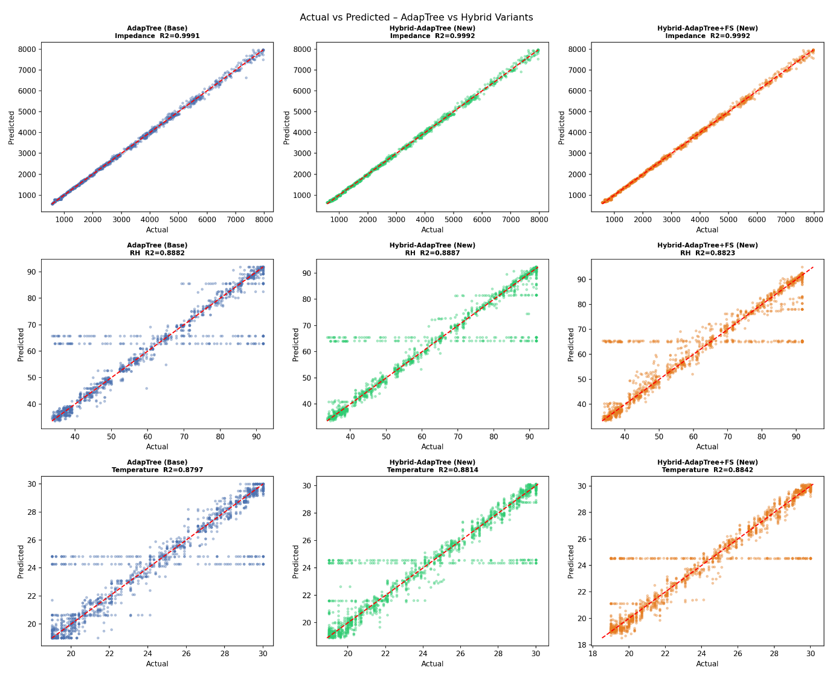
The scatter plots show how the actual and predicted values for impedance, relative humidity (RH), and temperature are related in both the AdapTree and the proposed Hybrid-AdapTree models. Ideally, points closer to the diagonal line indicate higher prediction accuracy.
For impedance, all three models have points that are very close to the diagonal, and the R² values are very high (about 0.999), which means that they are very good at making predictions. The Hybrid-AdapTree and Hybrid-AdapTree with Feature Selection are a little more in line with each other, which shows that they work better than the base AdapTree.For RH, the predictions are spread out moderately around the diagonal line, and the R² values are around 0.88. The Hybrid-AdapTree model aligns a little better than AdapTree, but the feature selection model works just as well.Again, the predictions for temperature follow the diagonal trend, with R² values around 0.88. The Hybrid-AdapTree with Feature Selection shows a little better alignment, which means it generalizes better.
The plots show that the proposed Hybrid-AdapTree models make more accurate and consistent predictions, especially for impedance. They also keep performance stable for RH and temperature.

C. Model Comparison

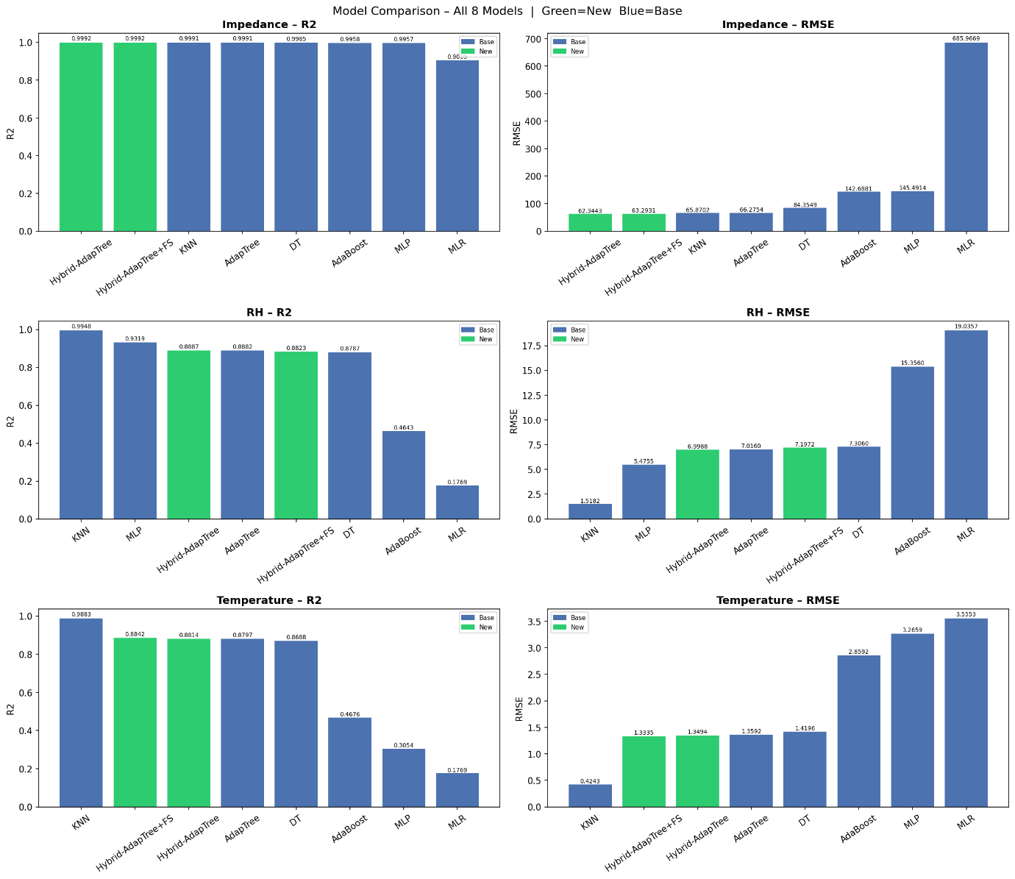
The R² and RMSE values for all the models show that the proposed Hybrid-AdapTree model is the best for predicting impedance. It has the highest R² value (about 0.9992) and the lowest RMSE value (about 62), which means it is very accurate. The Hybrid-AdapTree with Feature Selection works about the same, but with a little less error, and it also works better.
KNN works best for relative humidity (RH) and temperature because it has the highest R² and the lowest RMSE. This shows that it can handle these parameters well. The Hybrid-AdapTree models work well across all parameters, but not as well as single models that work well only in certain situations.Traditional models such as MLR show the poorest performance with high error values, while DT, AdaBoost, and MLP perform moderately.
Overall, the results indicate that Hybrid-AdapTree is best for impedance, while KNN is best for RH and temperature, and the proposed hybrid approach offers a balanced and robust solution for overall prediction

D. Training Time
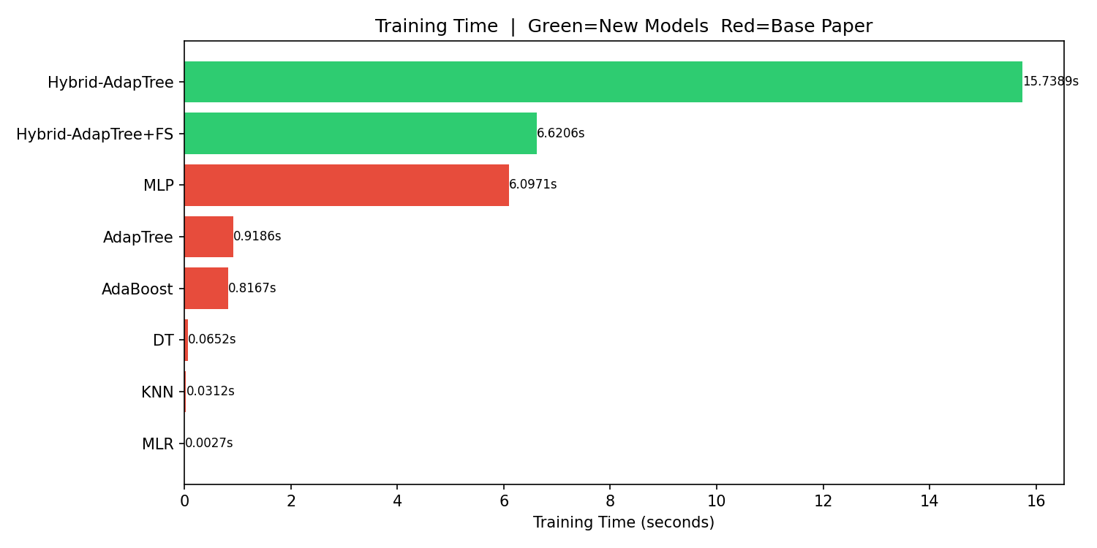
The comparison of training times shows that there is a clear trade-off between how complicated a model is and how quickly it can run. The Hybrid-AdapTree model, which is based on stacking and combines multiple learners, needs the most training time (about 15.7 seconds).
The Hybrid-AdapTree with Feature Selection, on the other hand, cuts training time down to about 6.6 seconds and improves performance by almost 53% while keeping accuracy the same. This shows that feature selection works to make things more efficient.
MLP also takes a long time to train (about 6.09 seconds), which is longer than simpler models like KNN, DT, and MLR, which take very little time to train but don't make as accurate predictions.In general, the results show that hybrid models are hard to compute, but adding feature selection makes them more useful for real-time applications because it cuts down on training time without hurting accuracy.

VII. Future Scope
Several natural extensions of the present work present compelling research directions:
- Integration of Additional Sensors: Future work can include more environmental parameters such as light intensity, soil nutrients, and CO₂ levels to improve prediction accuracy and provide a more comprehensive plant stress analysis.
- Real-Time IoT Implementation: The model can be deployed on embedded systems or IoT platforms for real-time monitoring and automated decision-making in smart agriculture systems.
- Application to Diverse Crops: Testing the model on different plant species and under varying field conditions can improve its generalization and make it applicable to large-scale agricultural environments.
- Advanced Model Enhancement: Incorporating deep learning or hybrid ensemble techniques can further improve prediction performance, especially for complex parameters like humidity and temperature.
- Explainable AI and Optimization: Applying explainable AI (XAI) techniques can improve model interpretability, while optimization methods can reduce computational cost and enhance real-time efficiency.

VIII. Conclusion
This work developed an improved machine learning framework for predicting environmental stress parameters like impedance, relative humidity (RH), and temperature using data from sensors. We used and tested several multiple regression models, and we suggested a Hybrid-AdapTree model to make predictions more accurate by combining the best parts of different learning algorithms.The results show that the suggested Hybrid-AdapTree model works better than other models, especially for predicting impedance, with very high accuracy (R² ≈ 0.999) and low error rates. KNN and other models do better for RH and temperature on their own, but the hybrid model works well for all parameters.
This shows how ensemble learning can find complicated nonlinear relationships in environmental and physiological data.The model is even better with feature selection using Mutual Information because it gets rid of less important features, lowers the number of dimensions, and makes the calculations faster. The Hybrid-AdapTree with Feature Selection cuts down on training time a lot while keeping the same level of accuracy, making it better for real-time use.
Moreover, the introduction of an Environmental Stress Index (ESI) helps in the comprehension of the predicted values through categorization according to the level of stress, which could help in making decisions regarding the agricultural systems. The presented technique is superior to existing models in both accuracy and efficiency. An efficient approach for monitoring environmental stress would be through the hybrid of ensemble learning and feature selection. This could be of great significance in areas such as precision agriculture and smart farming.

Application
The proposed framework has immediate applicability in the following contexts:
- Smart Irrigation Systems: Uses predicted humidity, temperature, and impedance to automate irrigation decisions, reducing water wastage.
- Plant Health Monitoring Systems: Detects early signs of plant stress using impedance-based analysis, improving crop yield and quality.
- IoT-Based Smart Farming: Can be integrated with IoT sensors and embedded systems for real-time monitoring and automated decision-making.
- Agricultural Decision Support Systems: Assists farmers and researchers in making data-driven decisions based on predictive analysis of environmental conditions.

Funding Details
No financial support was provided by any agency for the conduct of this study. This study was carried out using the facilities of the institution.

References
[1] H. M. Jawad, R. Nordin, S. K. Gharghan, A. M. Jawad, and M. Ismail, 'Energy-efficient wireless sensor networks for precision agriculture: A review,' Sensors, vol. 17, no. 8, p. 1781, 2017.
[2] K. G. Liakos, P. Busato, D. Moshou, S. Pearson, and D. Bochtis, 'Machine learning in agriculture: A review,' Sensors, vol. 18, no. 8, p. 2674, 2018.
[3] S. Adla, N. V. Rai, K. Karumanchi, S. Tripathi, A. Disse, and S. Pande, 'Laboratory calibration and performance evaluation of low-cost capacitive and very low-cost resistive soil moisture sensors,' Sensors, vol. 20, no. 2, p. 363, 2020.
[4] A. Sharma, E. Jain, P. Gupta, and V. Chowdary, 'Machine learning applications for precision agriculture: A comprehensive review,' IEEE Access, vol. 9, pp. 4843–4873, 2021.
[5] H. R. Bogena, J. A. Huisman, H. Schilling, A. Weuthen, and H. Vereecken, 'Effective calibration of low-cost soil water content sensors,' Sensors, vol. 17, no. 1, p. 208, 2017.
[6] F. Kizito et al., 'Frequency, electrical conductivity and temperature analysis of a low-cost capacitance soil moisture sensor,' Journal of Hydrology, vol. 352, no. 3–4, pp. 367–378, 2008.
[7] U. Rosenbaum, J. A. Huisman, J. Vrba, H. Vereecken, and H. R. Bogena, 'Correction of temperature and electrical conductivity effects on dielectric permittivity measurements with ECH2O sensors,' Vadose Zone Journal, vol. 10, no. 2, pp. 582–593, 2011.
[8] K. Ni, N. Ramanathan, M. N. H. Chehade, L. Balzano, S. Nair, S. Zahedi, E. Kohler, G. Pottie, M. Hansen, and M. Srivastava, 'Sensor network data fault types,' ACM Trans. Sensor Networks, vol. 5, no. 3, pp. 1–29, 2009.
[9] C. Zhang, D. Song, Y. Chen, X. Feng, C. Lumezanu, W. Cheng, J. Chen, G. Ni, B. Zong, and N. V. Chawla, 'A deep neural network for unsupervised anomaly detection and diagnosis in multivariate time series data,' in Proc. AAAI Conf. Artif. Intell., 2019, vol. 33, pp. 1409–1416.
[10] M. S. Hossain, G. Muhammad, and N. Guizani, 'Explainable AI and mass surveillance system-based healthcare framework to combat COVID-19 like pandemics,' IEEE Network, vol. 34, no. 4, pp. 126–132, 2020.
[11] D. J. Cook, N. C. Krishnan, and P. Rashidi, 'Activity discovery and activity recognition: A new partnership,' IEEE Trans. Cybern., vol. 43, no. 3, pp. 820–828, 2013.
[12] A. Chlingaryan, S. Sukkarieh, and B. Whelan, 'Machine learning approaches for crop yield prediction and nitrogen status estimation in precision agriculture: A review,' Comput. Electron. Agric., vol. 151, pp. 61–69, 2018.
[13] V. Sehgal, S. Sehgal, S. Bhatt, and A. Sehgal, 'IoT-based smart agriculture and farming,' in Proc. Int. Conf. Innov. Inf. Commun. Technol., 2019.
[14] S. Banerjee, R. Choudhary, and J. De, 'Precision agriculture: A data mining approach for prediction of soil properties,' in Proc. Int. Conf. Comput. Intell. Data Sci., 2020.
[15] N. Ahmed, D. De, and I. Hussain, 'Internet of Things (IoT) for smart precision agriculture and farming in rural areas,' IEEE Internet Things J., vol. 5, no. 6, pp. 4890–4899, 2018.
[16] P. Cunningham and S. J. Delany, 'k-nearest neighbour classifiers—A tutorial,' ACM Comput. Surv., vol. 54, no. 6, pp. 1–25, 2021.
[17] N. Papernot and P. McDaniel, 'Deep k-nearest neighbors: Towards confident, interpretable and robust deep learning,' arXiv preprint arXiv:1803.04765, 2018.
[18] P. Warden and D. Situnayake, TinyML: Machine Learning with TensorFlow Lite on Arduino and Ultra-Low-Power Microcontrollers. O'Reilly Media, 2019.
[19] J. Lim, J. Bae, and J.-H. Lee, 'Embedded system implementation of k-nearest neighbors with reduced computational complexity,' IEEE Embedded Syst. Lett., vol. 13, no. 2, pp. 62–65, 2021.
[20] J. Lee, F. Wu, W. Zhao, M. Ghaffari, L. Liao, and D. Siegel, 'Prognostics and health management design for rotary machinery systems—Reviews, methodology and applications,' Mech. Syst. Signal Process., vol. 42, no. 1–2, pp. 314–334, 2014.
[21] Q. Qi and F. Tao, 'Digital twin and big data towards smart manufacturing and Industry 4.0: 360 degree comparison,' IEEE Access, vol. 6, pp. 3585–3593, 2018.
[22] G. A. Susto, A. Schirru, S. Pampuri, S. McLoone, and A. Beghi, 'Machine learning for predictive maintenance: A multiple classifier approach,' IEEE Trans. Ind. Inform., vol. 11, no. 3, pp. 812–820, 2015.
[23] R. Lan, Y. Liu, G. Gao, Z. Lu, Y. Sun, and X. Luo, 'Survey of data quality issues in Internet of Things: Taxonomy, open challenges, and future research directions,' IEEE Access, vol. 9, pp. 6561–6576, 2021.
[24] A. Ault, J. Sorber, K. Kotz, and D. Bhatt, 'Remote sensing and IoT-based calibration for precision irrigation,' in Proc. ACM Int. Conf. Embedded Networked Sensor Syst., 2020.
[25] M. Goldstein and S. Uchida, 'A comparative evaluation of unsupervised anomaly detection algorithms for multivariate data,' PLOS ONE, vol. 11, no. 4, 2016.
[26] F. Pedregosa et al., 'Scikit-learn: Machine learning in Python,' J. Mach. Learn. Res., vol. 12, pp. 2825–2830, 2011.
[27] J. S. Camargo, A. F. Lima, M. A. S. Trindade, L. R. Manzione, and J. C. Bereta, 'A low-cost IoT sensor node for monitoring soil parameters and its application in precision agriculture,' Sensors, vol. 21, no. 16, p. 5414, 2021.
[28] S. Wolfert, L. Ge, C. Verdouw, and M. J. Bogaardt, 'Big data in smart farming—A review,' Agric. Syst., vol. 153, pp. 69–80, 2017.
[29] Z. Kaleem, A. Rehan, M. Rehan, M. S. Khan, and C. R. Anderson, 'Low-power wide-area IoT networks for smart agriculture,' in Proc. IEEE Int. Conf. Signal Process. Commun., 2019.
[30] J. Schmidhuber, 'Deep learning in neural networks: An overview,' Neural Networks, vol. 61, pp. 85–117, 2015.

